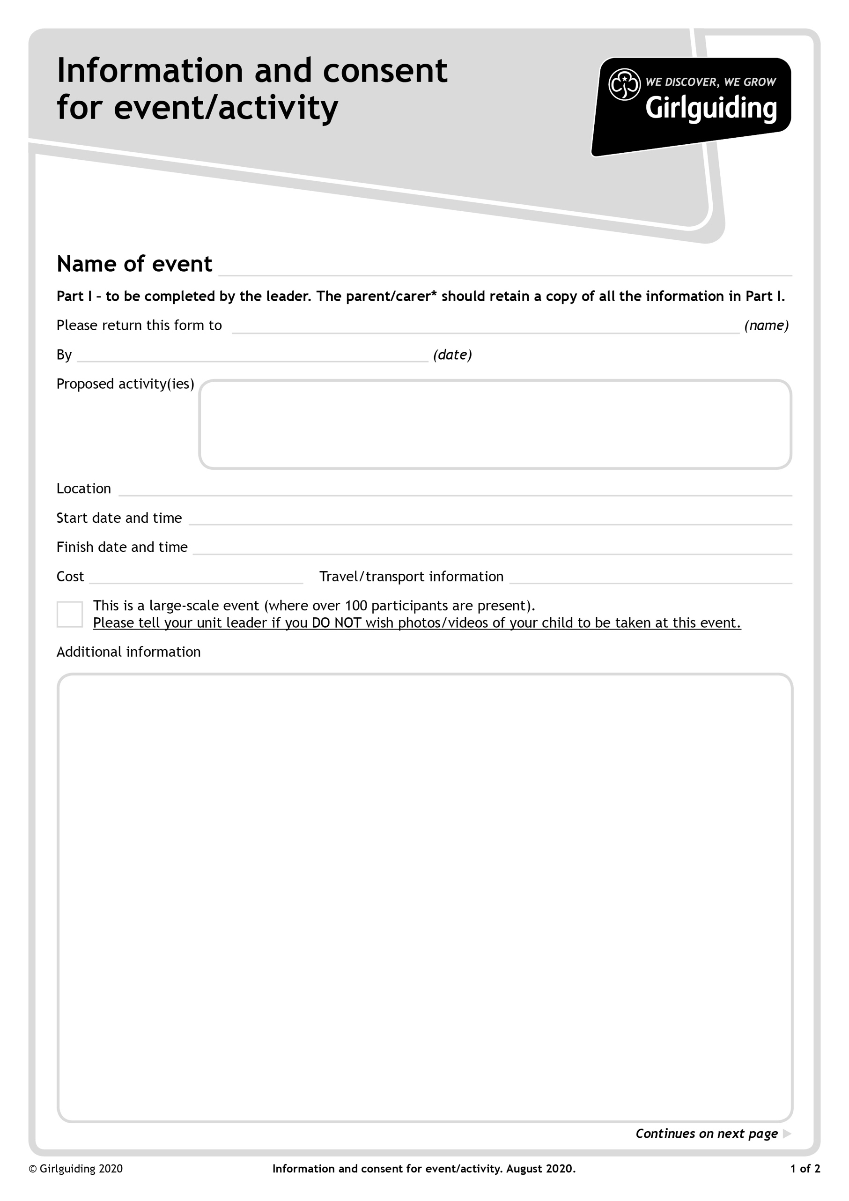
£40 by 2nd June and £45 by 27th June giving a total of £85
Public transport departing from Oxenholme or Barrow station depending on home location

Travel to and from Manchester by public transport.
Indoor skydiving at ifly Manchester on Friday Eve
Sleep over at Premier Inn before Sledge and slide, downhill doughnuts and ice slide at Chill Factore, all rounded off with some time shopping at the Trafford centre.
We will be leaving from either Barrow or Oxenholme station depending on where is closest at around 4.30pm depending on trains.(please indicate below which station you would prefer)
Travel to Manchester Trafford, having a packed tea from home on the train and go straight to Ifly for 2 flights each. Walk round the corner to Premiere Inn where girls will share rooms with each other. After breakfast in the hotel we will walk round the corner to Chill Factore to enjoy the Snow Parks Ice slide , sledge and slide and downhill doughnuts. We will then wander round to the Trafford Centre so the girls can explore the shops before travelling home on public transport.

The girls will need long sleeve tops and bottoms as well as gloves for the snow park.
They will also need a small overnight bag, preferably a rucksack, that they can just put on their backs as they will need to carry them around for the day so best to keep it light. Premier Inn will provide towels and bedding.

Everyone will need a packed tea to eat on the way down.

I would like to travel from Oxenholme / Barrow

Please return the attached form along with the deposit of £40 by 2nd June and then a further £45 by the 27th June if preferred you can pay the balance of £85 in the first payment.
Cheques to be made payable to Girlguiding Cumbria South.
To Lindsey Cooper, 7 Claife Close, Windermere, Cumbria, LA23 2LL.
Any questions please email outdoors @girlguidingcumbriasouth.org.uk
2nd July 2022 7.30pm (depending on trains)
1st July 2022 4.30pm (depending on trains)
Manchester Ifly, Chill factore, Trafford Centre and staying at Premier Inn Trafford Centre West.
3rd June 2022
Freeze and fly sleepover in Manchester for Rangers and Young leaders (14-18)
Lindsey Cooper, 7 Claife Close, Windermere, Cumbria, LA23 2LL

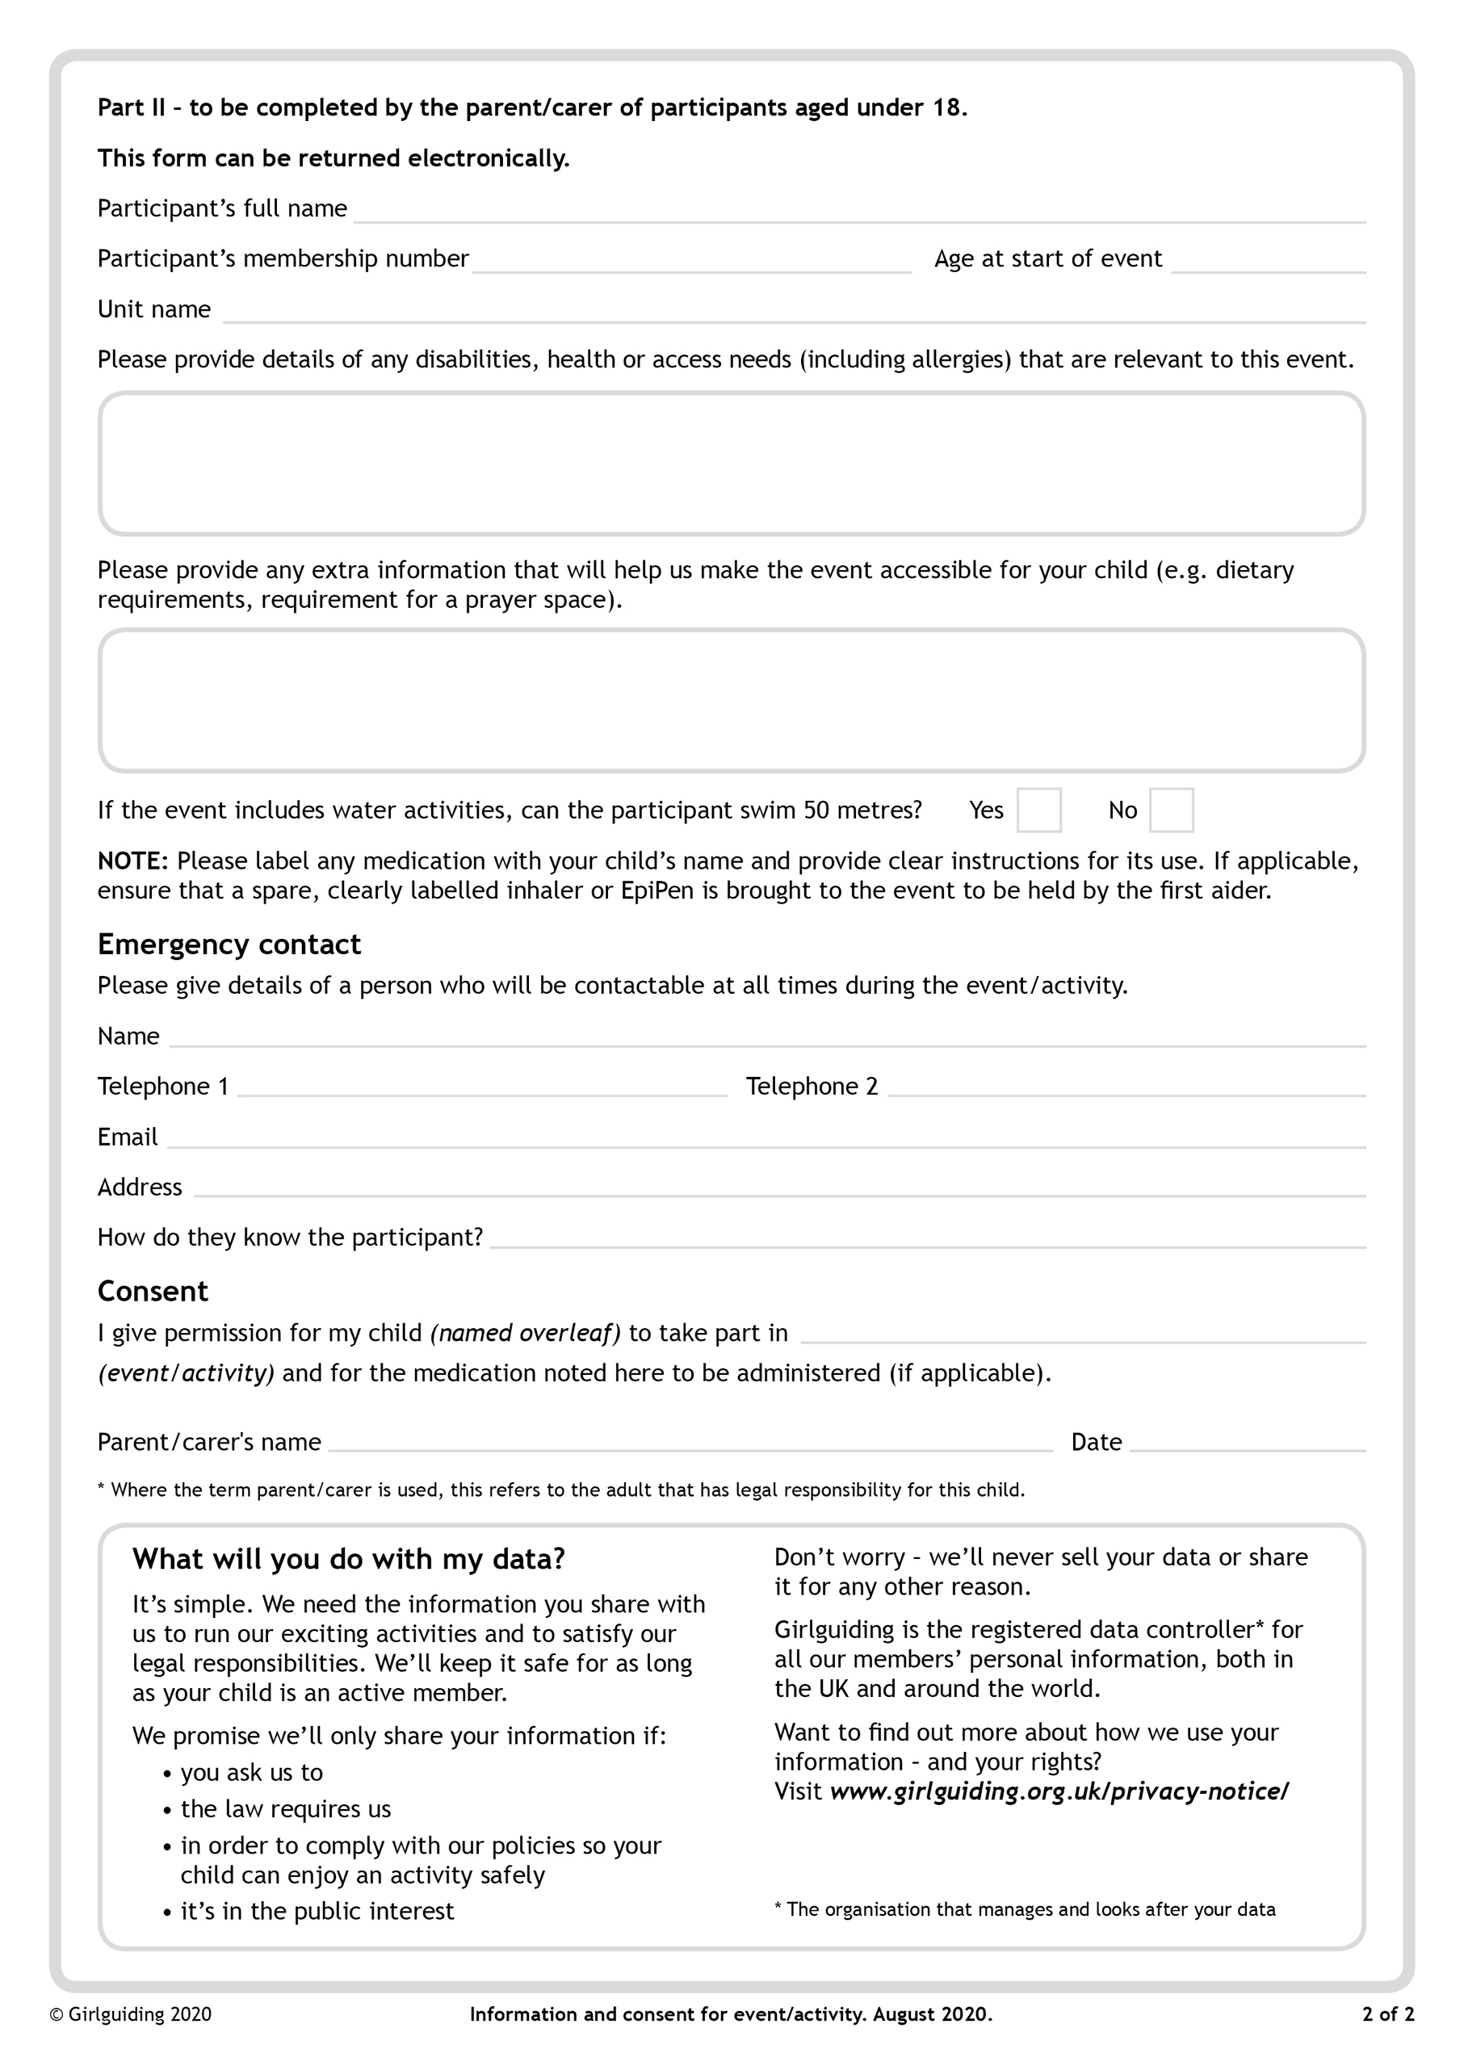

Freeze and fly sleepover in Manchester

