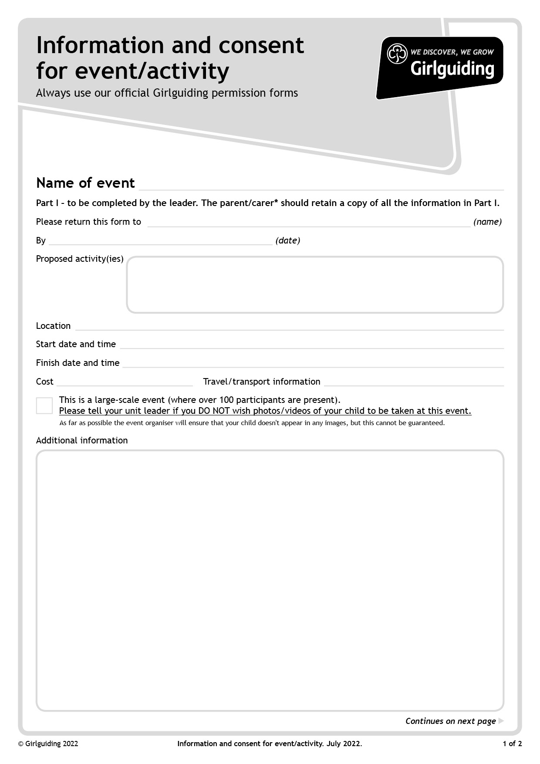
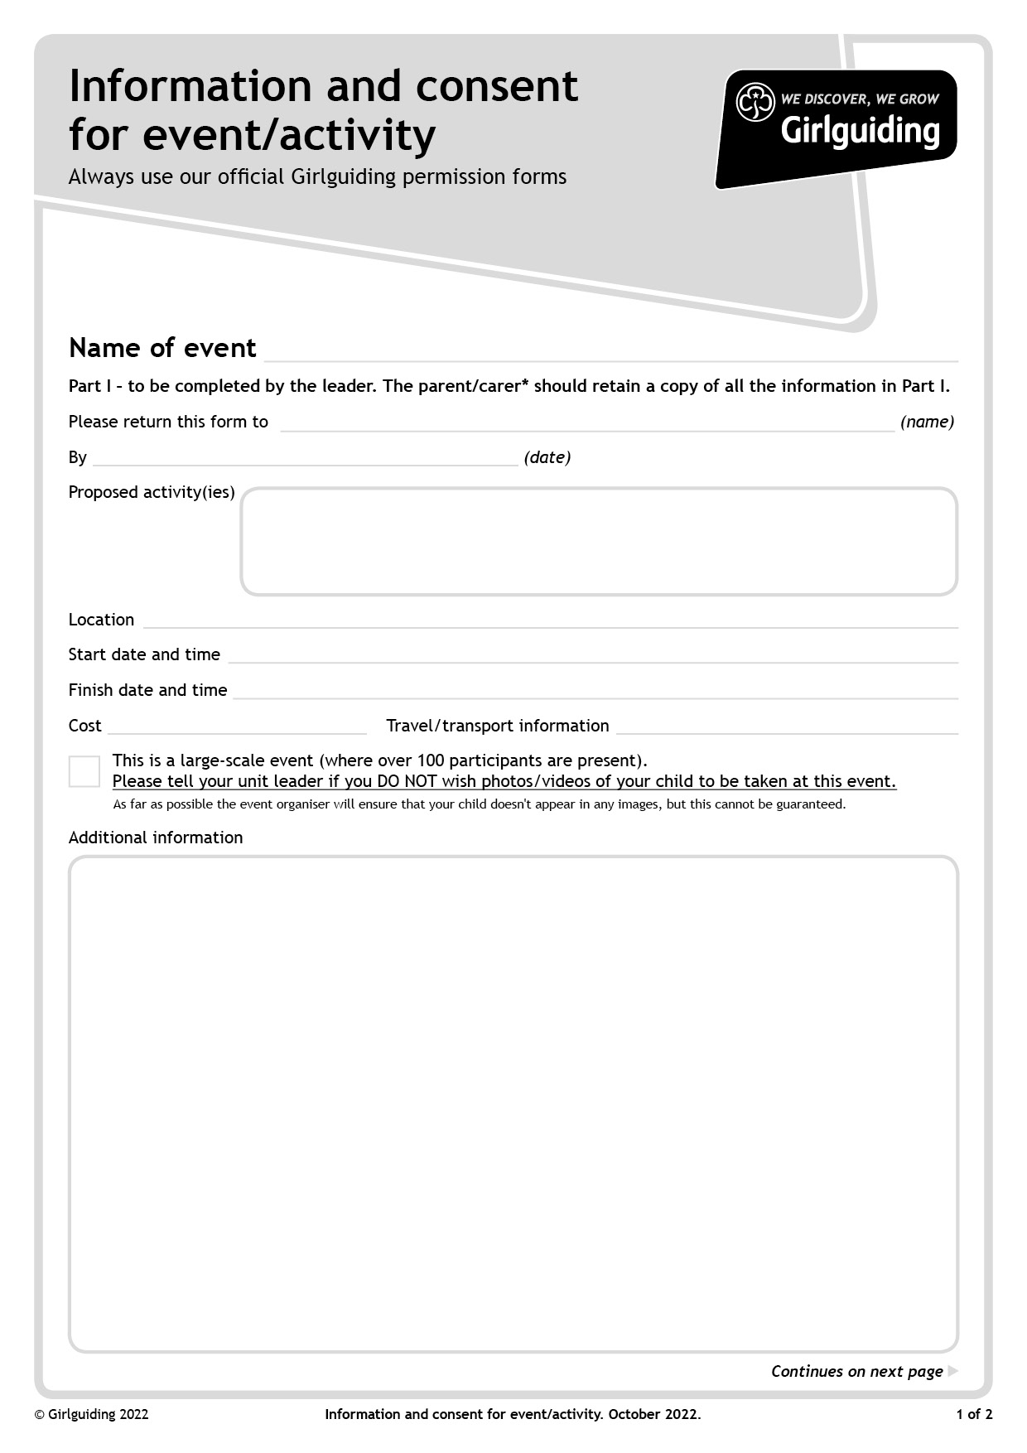
£3.50 + £2.00 for ice-cream
Matilda the Musical

The Roxy Cinema, Ulverston
11/12/22 - Arrive from 10.30, Film starts at 11.00
11/12/22 - 13.15pm
Parents responsible for.

Uniform to be worn – the Roxy can be cool sometimes, so it is recommended that hoodies are worn if individuals have them. If not, bring another layer to wear over their uniform T-shirt.

Ice-cream will be served during the interlude, to those who have ordered it. If your Rainbow/Brownie/Guide is lactose intolerant, and you have notified your leader, a dairy free alternative will be provided.

Dropping off – please do not park right by the Roxy as space is very limited and there will be lots of young members about. Parent/carers to drop their daughter/ward off, with their leader outside the cinema or, if wet, upstairs in the foyer.

Collecting – please find somewhere to park, away from the Roxy, and collect your daughter/ward from their leader outside the cinema or inside if it is raining.

Please be aware that there will be lots of young members at this event and it is very important that leaders make sure every girl is collected safely So please be patient.whilst waiting. Thank you.

Watching Matilda the Musical

