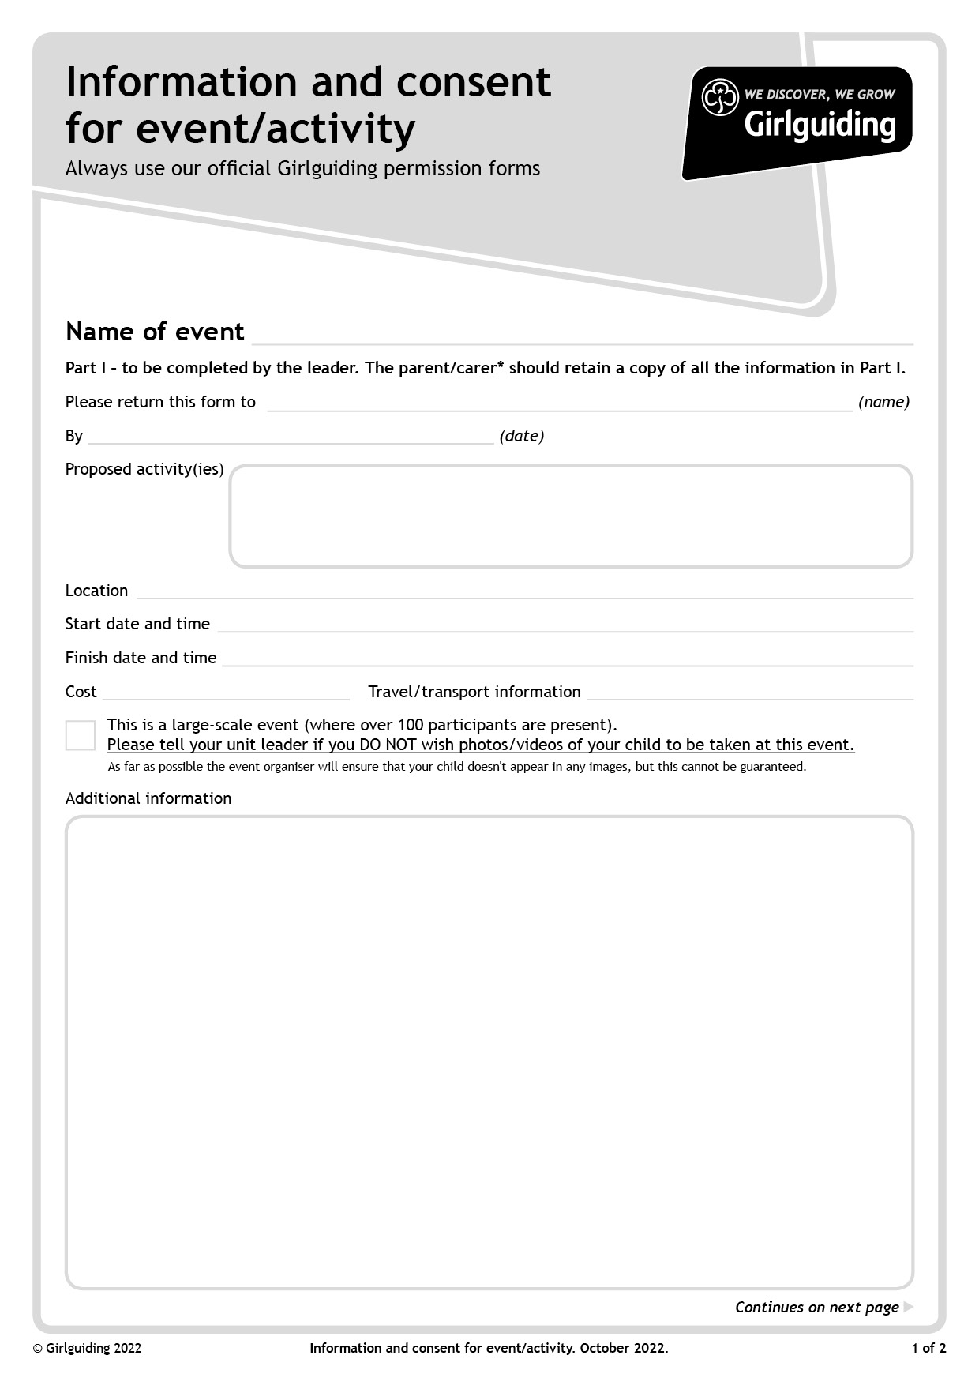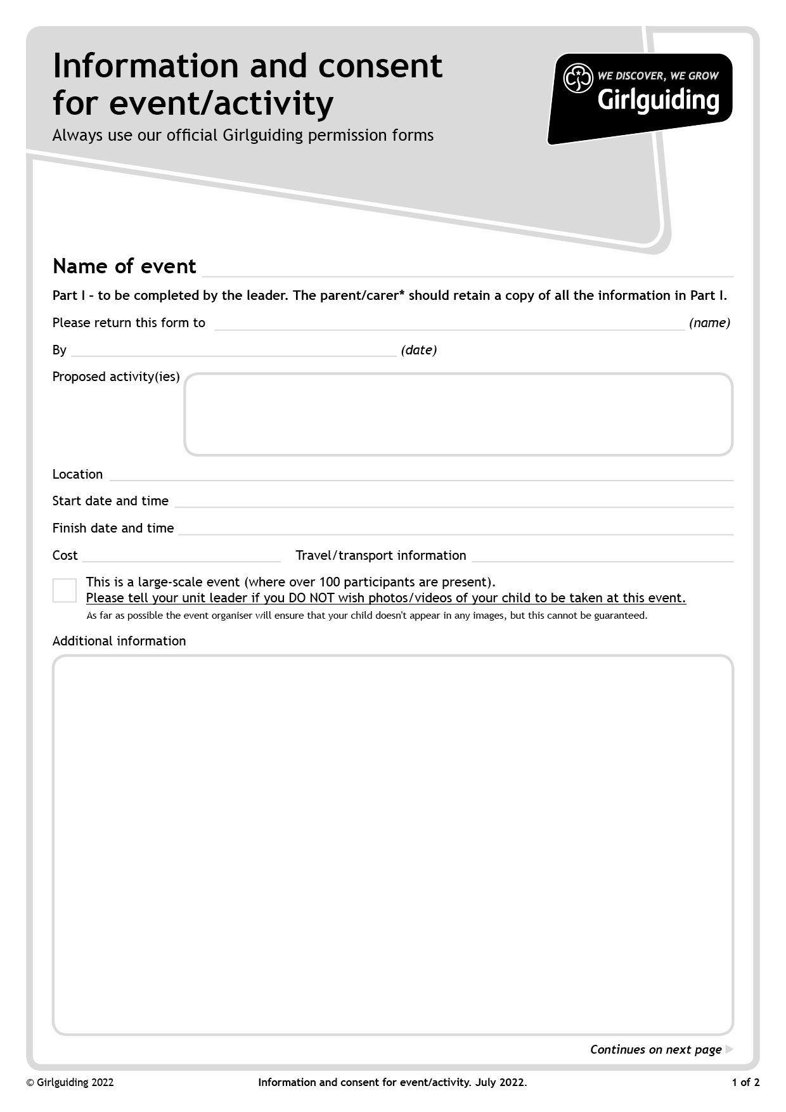

£3.50 + £2.00 for ice-cream

Matilda the Musical

The Royalty Cinema, Bowness

11/12/22 - Arrive from 10.30, Film starts at 11.00

11/12/22 - 13.15pm

Parents responsible for.

Uniform to be worn

Ice-cream will be served during the interlude, to those who have ordered it. If your Rainbow/Brownie/Guide is lactose intolerant, and you have notified your leader, a dairy free alternative will be provided.

Dropping off – please drop young members off in the car park, at the side of the Royalty, where leaders will be waiting to take them into the cinema.

Collecting – please collect young members from their leaders, in the car park..

Please be aware that there will be lots of young members at this event and it is very important that leaders make sure every girl is collected safely So please be patient.whilst waiting. Thank you.

Watching Matilda the Musical

